Supplementary Information for the Manuscript:
“Unusual trinuclear complex of Copper (II) containing a 4'-(3-methyl-2-thienyl)-4,2':6',4''-terpyridine ligand. Structural, spectroscopic, electrochemical and magnetic properties”
By the authors:
Dominique Toledoª, Guillermo Ahumada^{b,c}, Carolina Manzur^{b}, Thierry Roisnel^{c}, Octavio Peña^{c}, Jean-René Hamon^{c}, Jean-Yves Pivan^{c,d}, Yanko Moreno^{e*}

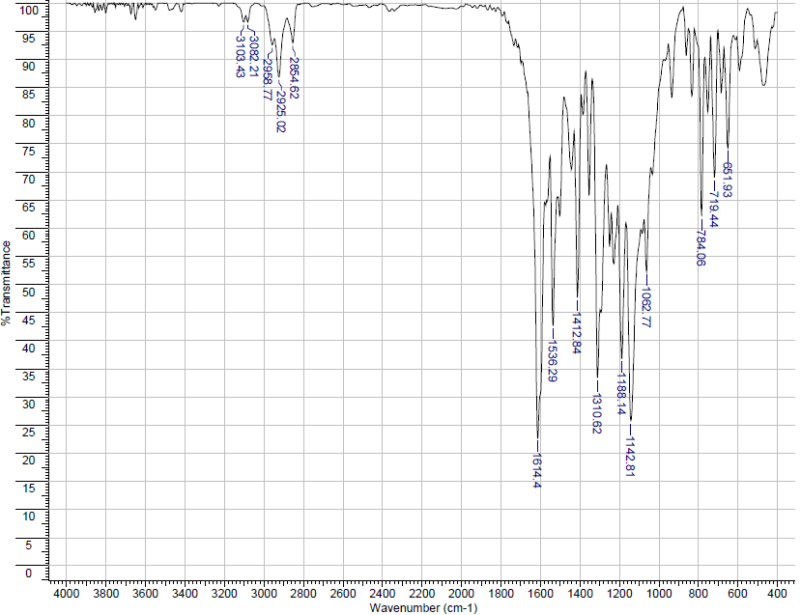
Fig. S1. FT-IR spectra of complex 1.
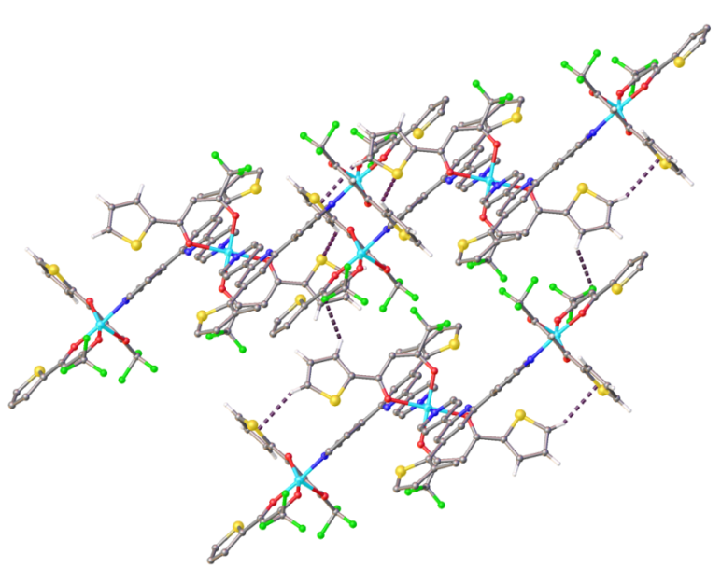
Fig. S2. Packing view of intermolecular Hydrogen Bonds in complex 1 projected along the [001] direction.

Table S1. Intermolecular hydrogen bonds in complex 1.
D-H···A | d(D···H)(Å) | d(H···A)(Å) | d(D···A)(Å) | <(D-H···A) (°)
C(8A)–H(8A) Cg(9)^{ii} | 0.95 | 2.95 | 3.795(6) | 148
C(6C)–H(6C) F(4BC)^{iii} | 0.95 | 2.54 | 3.469(11) | 167
C(6B)–H(6B) S(2)^{iv} | 0.95 | 2.87 | 3.591(6) | 134
Symmetry codes: (ii) 2-X,1-Y,-1-Z ; (iii) -x,2-y,-1-z ; (iv) -1+x,1+y,-1+z

Fig. S3. Packing view of C-F···π Interactions in complex 1 projected along the [110] direction. Hydrogen atoms are omitted for clarity.

Table S2. C-F···π Interactions in complex 1.
D-F···A | d(D···F)(Å) | d(F···A)(Å) | <(D-F···A) (°)
C(4C)–F(4CC)---Cg(8)^{v} | 1.321(5) | 3.741(4) | 103.5(3)
Symmetry codes: (v) -1+X,1+Y,Z

Fig. S4. Packing view of π-π interactions in complex 1. Hydrogen atoms are omitted for clarity.

Table S3. π-π interactions in complex 1.
Group 1/Group2 | ccd (Å) | da (°) | ipd (Å) | sa(°)
Cg(18)···Cg(18) ^{ii} | 3.502(4) | 0.0(4) | 3.337(3) | 1.063(5)
Cg(10)···Cg(18)^{vi} | 3.961(3) | 2.38(19) | 3.467(4) | 1.804(13)
Cg(18) is the centroid of the N2 /C6-C10 pyridine ring and Cg(10) is the centroid of the S4/ C5B-C8B thienyl ring. Symmetry codes; (ii) 2-X,1-Y,-1-Z ; (vi):- 1-X,2-Y,-1-Z.
Note: ccd is the centre-to-centre distance (distance between ring centroids); da is the dihedral angle between rings; ipd is the interplanar distance (distance from one plane to the neighbouring centroid), sa is the slippage angle (angle subtended by the intercentroid vector to the normal plane) [1].

[1] C. Janiak, J. Chem. Soc., Dalton Trans. (2000) 3885-3896.

