Supporting Information

1. UV-visible

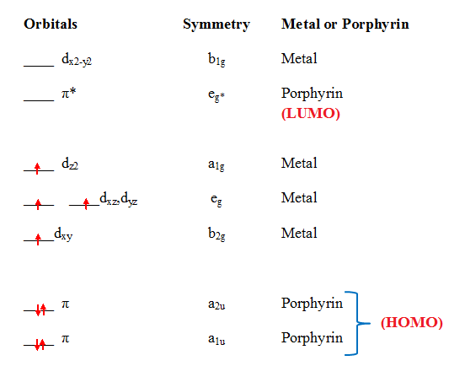
Figure SI-1. Energy levels of the frontier orbitals of manganese(III) metalloporphyrins.

2. Crystallography
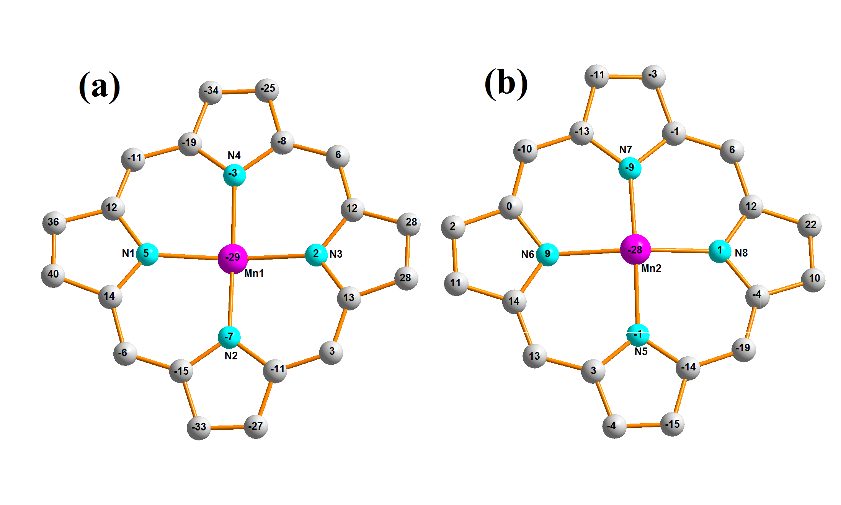
Figure SI-2. Formal diagrams of the porphyrinato cores of [Mn^{III}(TPP)(OAc)] (a): first molecule in the asymmetric unit and (b): second molecule in the asymmetric unit. The displacement of each atom from the mean plane of the 24-atom porphyrin macrocycle in given in unit of 0.01 Å.
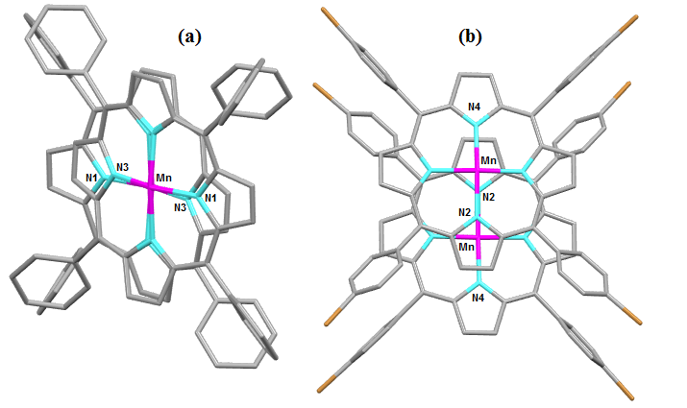

Figure SI-3. Projection showing the parallel superposition of the vectors joining opposite nitrogen atoms of the two macrocycles of one dimer, (a): complex 1 and (b): complex 2.
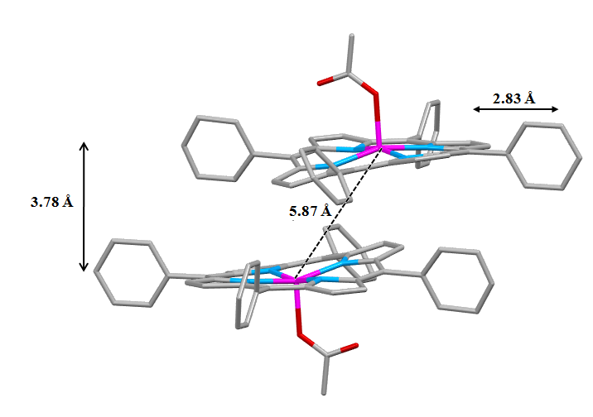

Figure SI-4. Schematic representations of one dimer of the [Mn^{III}(TPP)(OAc)] complex.

Table SI-1. Hydrogen bonds and Selected C–H···Cg intermolecular interactions for 1-2.
_________________________________________________________________________________________
Complex Dª···A^{b} [Å] D–H···A
__________________________________________________________________________________________
Complex 1
C23-H23…O2^{[i]} 3.308 (6) 155
C35-H35…O1^{[ii]} 3.301 (5) 135
C41-H41…Cl3A^{[iii]} 3.614 (5) 146
C41-H41…O2^{[iii]} 3.252 (6) 144

C22-H22…Cg3^{[iv]} 3.402 (4) 119
C24-H24…Cg4^{[i]} 3.437 (5) 139
C31-H31…Cg12^{[vi]} 3.600 (5) 155
C35–H35…Cg1^{[ii]} 3.692 (6) 141
C38–H38…Cg9^{[v]} 3.828 (5) 155
C44–H44…Cg10 ^{[iv]} 3.737 (4) 151

Complex 2
C7-H7…Cl4A^{[i]} 3.290 (13) 156
C29-H29…O1^{[ii]} 3.190 (8) 128
C34-H34…Cl4A ^{[iii]} 3.497 (14) 144
C22–H22…Cg10 ^{[iii]} 3.742(8) 144
C29–H29…Cg6^{[iii]} 3.617(7) 126
C32–H32…Cg1^{[iv]} 3.562(7) 140
__________________________________________________________________________________________
ª D = donor atom,^{b} A = acceptor atom.
Complex 1:
Cg1 is the centroid of the N1/C1-C4 five-member ring, Cg3 is the centroid of the N3/C8-C11 five-member ring. Cg4 is the centroid of the N4/C13-C16 five-member ring, Cg9 is the centroid of the C21–C26 six-member ring. Cg10 is the centroid of the C27–C32 six-member ring, Cg12 is the centroid of the C39–C44 six-member ring.
Symmetry codes : (i)-1+x,y,z; (ii) -x,1-y,1-z ; (iii) -1/2+x,1/2-y,1/2+z ;(iv) -x,-y,-z ; (v) 1/2-x,1/2+y,1/2-z ; (vi) x,y,-1+z.
Complex 2:
Cg1 is the centroid of the N1/C1-C4 five-member ring, Cg10is the centroid of the C27-C32 six-member ring.
Cg11 is the centroid of the C21–C26 six-member ring.

Symmetry codes: (I) -x,1-y,1-z; (ii) x,y,z; (iii) 2-x,1-y,1-z ;(iv) 1-x,1-y,1-z.
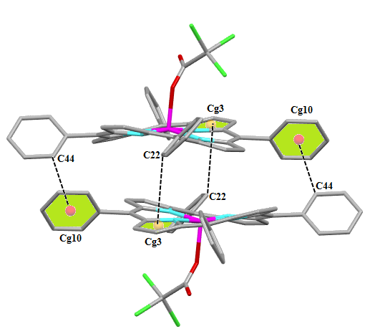

Figure SI-5. Schematic representation of the C__H…Cg intermolecular interactions in complex 1 where Cg is the centroid of a phenyl ring of the TPP porphyrinate.
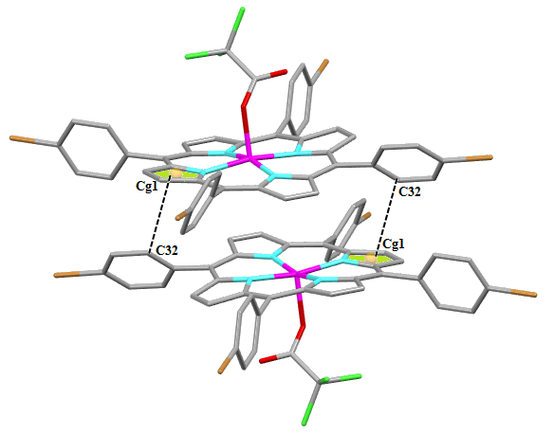

Figure SI-6. Schematic representation of the C__H…Cg intermolecular interactions in complex 1 where Cg is the centroid of apyrrole ring of the TBrPP porphyrinate.

