Supporting information to the paper
Rapinel, S. et al. Mapping grassland plant communities using a fuzzy approach to address floristic and spectral uncertainty. Applied Vegetation Science.

Appendix S6. Importance of spectral bands on classification accuracy

The influence of spectral bands on the overall accuracy of the classification is presented in the figure below. When removed individually or pairwise, the visible spectra bands (b1, b2 and b3) have little importance since the overall accuracy (OA) of the classification slightly increases (+ 1%). Conversely, the influence of the near infra-red spectral band (b4) and LiDAR band (b5) is more significant since the OA of the classification decreases by 2 and 5% respectively when either b4 or b5 are removed individually. When these two bands are jointly removed, the OA of the classification even decreases by 10%. Interestingly, the OA of the classification decreases with a similar trend (-10%) when all of the visible spectra bands are removed. 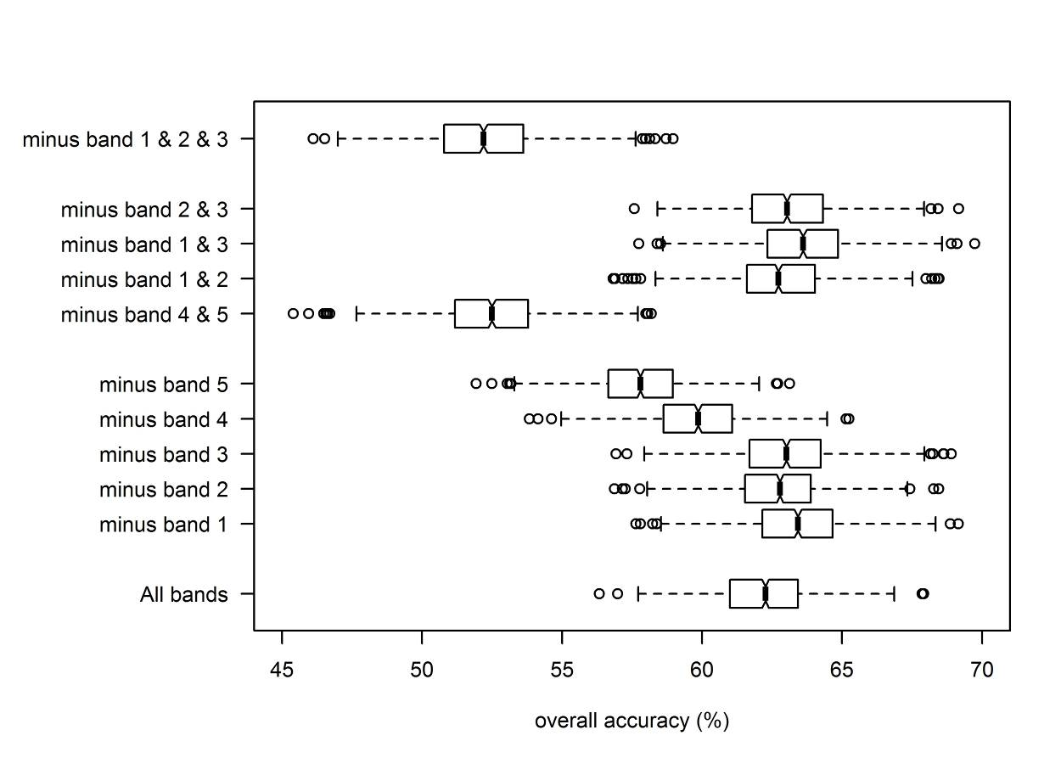
Fig. Influence of spectral bands on the overall accuracy of the classification

